**Retail Analysis with Walmart Data**



* In this report we are going to discuss the retail analysis with Walmart data of the historical data that covers sales from 2010-02-05 to 2012-11-01 using python language and the process will be as follow:

1. Importing Data

2- display data

3- visualize quantitative variables distributions

4- perform data cleaning

* First:

We will import our packages which are NumPy, pandas, matplotlib and seaborn to help us in performing our data in a suitable way and in making our calculations and at the end visualizing our data will direct us to be aware of the end goal we have mind.

* Second:

We will display our data: -

* Third:

We will do some operations on our data in order to visualize data much easier as wanted in the assignment.

* Fourth:

Looking at the data we can see that its already a clean dataset.

* For example: there is no rows that contains NAN values to be dropped.
* **Now we are going to perform some needed calculations on the dataset:**

a-Identifying the store that has the maximum sales.

b- Identifying the store that has the maximum standard deviation.

c-

**First**: We are going to calculate the mean value of the non-holiday’s weeks: -

**Second**: we are going to find out holidays that have higher sales than the mean sales in the non-holiday season for all stores together.

d- Providing a monthly and semester view of sales in units, here is some sample rows:

e-1-we have scatter graph between Weekly sales and Stores

2- We will represent the CPI of Data

3-we have a graph between Weekly sales and Fuel Price

**Fuel Price has no effect in the weekly sales**

3-we have a graph between Weekly sales and temperature

**temperature has no effect in the weekly sales**

second, we have a graph between Weekly sales and Fuel_Price

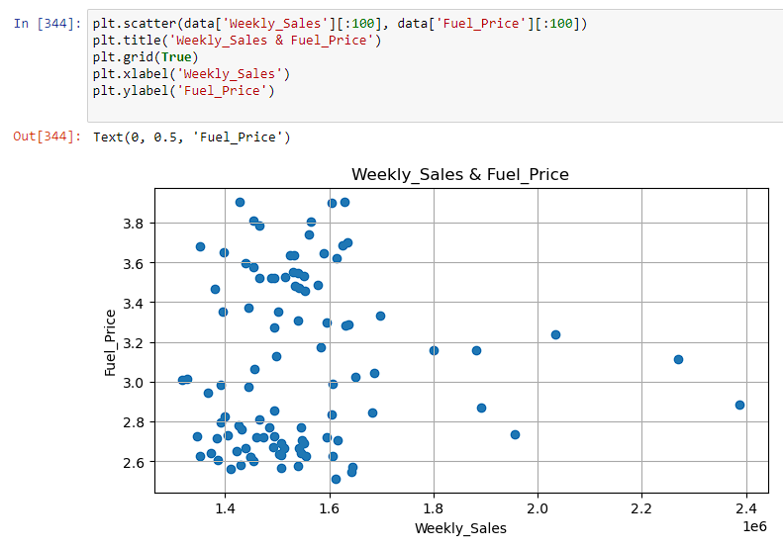

Third, we have a graph between Weekly sales and CPI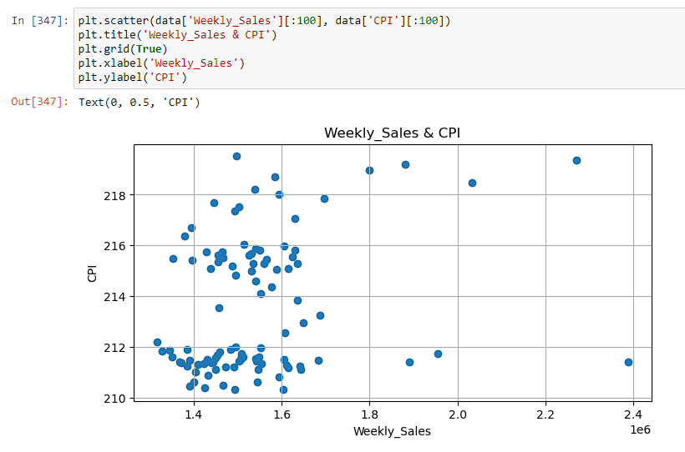

fifth we have a graph between Weekly sales and Holiday_Flag

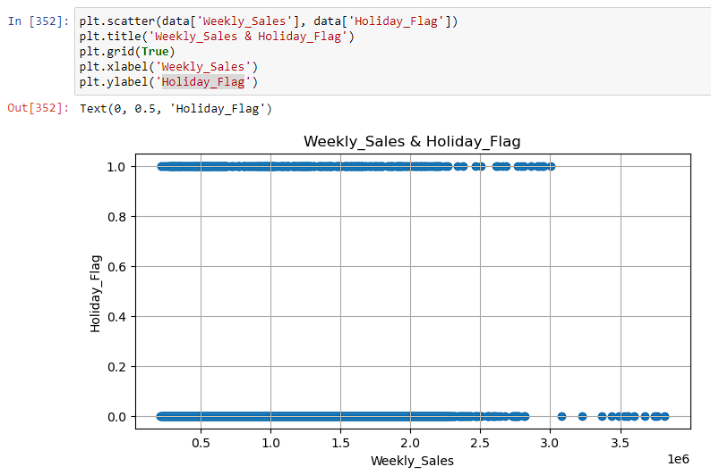

* And the last plot we have is to summarize all these relations which is a heatmap that identifies positive and negative correlations between weekly sales and all other numeric variables.

**And that’s everything … We apologize for elongating, and lengthiness.**

**Hope we met all the requirements. 😊**

**Thanks…**